LAB LOGBOOK
LAB 1:
DataFrame: This is the primary Pandas class for two-dimensional labeled data structures with columns of potentially different types, acting like a powerful spreadsheet or SQL table.
Series: Representing a one-dimensional labeled array, Series is fundamental for handling single columns of data within a DataFrame or as standalone data.
Categorical: This class efficiently stores and manipulates categorical data, which can significantly reduce memory usage and speed up computations for repetitive string values.
Grouper: Used primarily with groupby operations, Grouper allows for convenient grouping of data based on time intervals or other criteria, especially useful for time-series analysis.
Index: The Index class provides the labeled axes (rows and columns) for DataFrame and Series objects, enabling efficient data alignment and selection.

LAB 2:
Source website: https://www.cisa.gov/news-events/cybersecurity-advisories/aa21-131a
Step 1. Chosen Topic: Colonial Pipeline Ransomware Attack (2021)
This attack disrupted fuel distribution across the eastern United States and highlighted the vulnerability of critical infrastructure to cyber threats.

Step 2: Research the Attack
- How did the attack happen?

It occurred when cybercriminals gained access to Colonial Pipeline’s internal network through a compromised VPN account.

Technical weaknesses included:

-An inactive VPN account that was still enabled

-Use of a single-factor authentication VPN

-Use of a single-factor authentication VPN

Once inside the network, attackers deployed ransomware, encrypting systems and forcing Colonial Pipeline to shut down operations as a precaution.

2.Who were the attackers?

-The attackers were identified as DarkSide, a financially motivated ransomware group operating as a Ransomware-as-a-Service (RaaS) organization.

- What was the impact?

Operational Impact

-Fuel shortages and panic buying across multiple U.S. states

-Disruption of nearly 45% of the U.S. East Coast fuel supply

-Pipeline shutdown lasting several days

Financial Impact

-Colonial Pipeline paid approximately $4.4 million USD in ransom (partially later recovered by U.S. authorities)

- Additional losses from downtime and remediation costs

Reputational Impact

-Loss of public trust

-Increased scrutiny on critical infrastructure cybersecurity

- How was it discovered?

The attack was discovered when employees noticed systems becoming unavailable and files encrypted.
Colonial Pipeline’s internal security team confirmed ransomware activity and proactively shut down pipeline operations to prevent further damage.

Step 3: Cause Analysis and Mitigation

1. Why did the attack succeed?
The attack succeeded due to several security gaps:
- Lack of multi-factor authentication (MFA) on VPN access
- Poor credential hygiene, including password reuse
- Inactive accounts not properly disabled
- Limited network segmentation between IT systems and operational technology (OT)
- Insufficient monitoring for suspicious login activity

LAB 3:
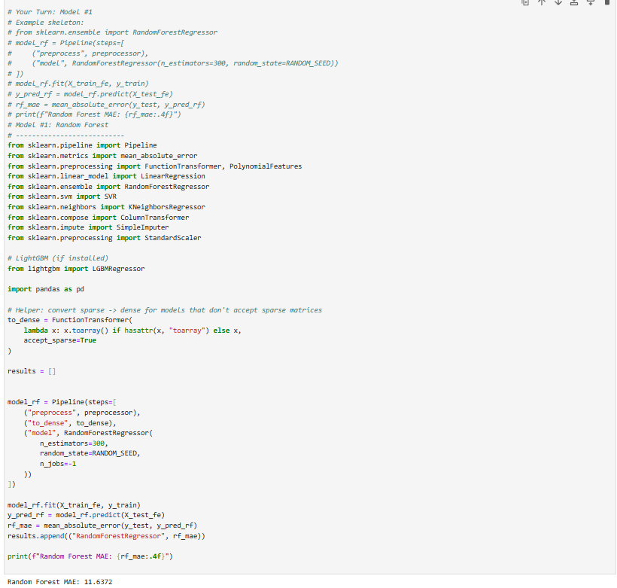
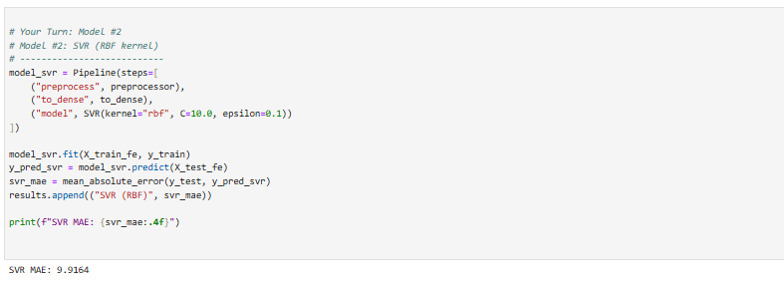
LAB 4:

